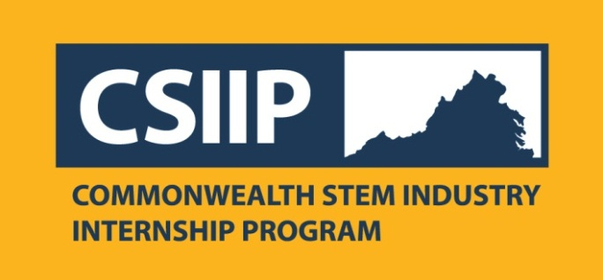
Commonwealth STEM Industry Internship Program
Connects Virginia students with high-quality paid internships in the STEM industry

Contact: For Release: October 11, 2013
John Iacobucci
Program Manager, Commonwealth STEM Industry Internship Program
757-766-5210; mailto:jiacobuc@odu.edu

Hampton. Va. - College and University students majoring in science, engineering, technology and math (STEM) related fields have a free resource for finding paid internships, as do companies who wish to hire them.
Now in its second year, the expanded Commonwealth STEM Industry Internship Program (CSIIP) offers a no-cost, centralized, online application system that allows Virginia undergraduate college students majoring in STEM the ability to search and apply for paid, STEM-related internships with Virginia companies. Additionally, it provides Virginia companies with year-round free access to a large state-wide pool of qualified students for their internship opportunities. Students provide one comprehensive application that can be reviewed by companies throughout the state. The CSIIP website is: CSIIP.ORG
The 2014 program has been broadened to include internships in spring, summer and fall. In addition to full-time students, part-time students meeting certain criteria may now also use the program. Students must be STEM majors, at least a rising college sophomore at the time of internship, and attending a Virginia college or community or be a Virginia resident if attending an out-of-state school. The minimum grade point average for consideration is 2.7 on a four-point scale.
Students receive statewide consideration for available internships, but can also express interest in specific internships or in specific regions of the state. Participating companies can search the applicant pool via an enhanced sophisticated search and sort tool to look at applicants by major, skills, colleges, geographic proximity and key-word searches. Companies will make selections, interview, and hire students directly. Hourly rates will be determined by the company, but a minimum rate has been established.
The Virginia Space Grant Consortium (VSGC) offers the Commonwealth STEM Industry Internship program with funding from the Commonwealth of Virginia. Partners include: New College Institute, Virginia’s regional technology councils, the Virginia Manufacturers Association’s Dream !t, Do !t® Virginia initiative, the Virginia Society for Human Resource Management and Systemic Solutions of Northern Virginia.
Students should apply now, as a number of companies begin making summer and spring internship selections as early as December. Companies are encouraged to register as soon as possible and to list internship opportunities in the system for maximum exposure. Visit the site at http://www.csiip.spacegrant.org/ to apply, register your company or learn more.
In its 2013 pilot year, CSIIP demonstrated its ability to place students in STEM internships throughout the Commonwealth. VSGC Director Mary Sandy notes that, “Internships offer paid real-world work experiences to students in their majors. These experiences are wonderful ways for students to gain experience and to put their academic skills to use, and for companies to consider these individuals for future employment opportunities.” She adds, “CSIIP is designed to give students exposure to many companies with one application and to provide employers with a diverse pool of high qualified, pre-screened STEM applicants. CSIIP helps both Virginia companies and students make these important workforce connections.”
The Virginia Space Grant Consortium is a coalition of five Virginia colleges and universities, two NASA centers, state educational agencies, including the State Council of Higher Education for Virginia and the Virginia Community College System, Virginia's Center for Innovative Technology, and other institutions representing diverse aerospace and high technology education, workforce development and research interests. Part of NASA's Space Grant program, the VSGC acts as an umbrella organization, coordinating and developing high technology educational, workforce development and research efforts throughout the Commonwealth and connecting Virginia's effort to a national community of shared aerospace and high tech interests. Other VSGC offerings include: scholarships, fellowships, NASA internships, teacher/faculty professional development, student flight programs, pre-college student programs, and informal educational programs. Visit the VSGC website at www.vsgc.odu.edu.
# # #

