Professional DJ Services, Harp, String Ensembles, and Specialty Lighting

Specializing in Weddings, Reunions, Birthdays and Corporate Events

Music, Music, & More Music has been rated the top DJ Service in Southwest Virginia by brides on the Knot.com website for 2012, 2013, & 2014. We have 6 Mobile Disk Jockeys available and are members of the National Association of Mobile Entertainers, (N.A.M.E). Our “home” area is Wytheville to Charlottesville, Hot Springs to North Carolina. Additional distance is available with a custom travel quote.

Wendell Witt, owner, was born & raised in Bedford County Virginia where he graduated from Staunton River High School, attended Virginia Western Community College and Lynchburg College. After a 4-year apprenticeship, he completed a program through Central Virginia Community College. He currently resides in Bedford County and has been a Professional DJ since 1998.

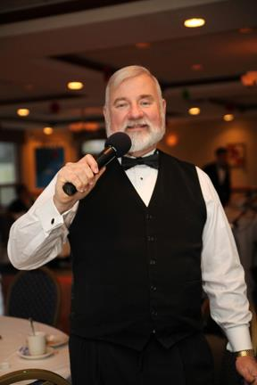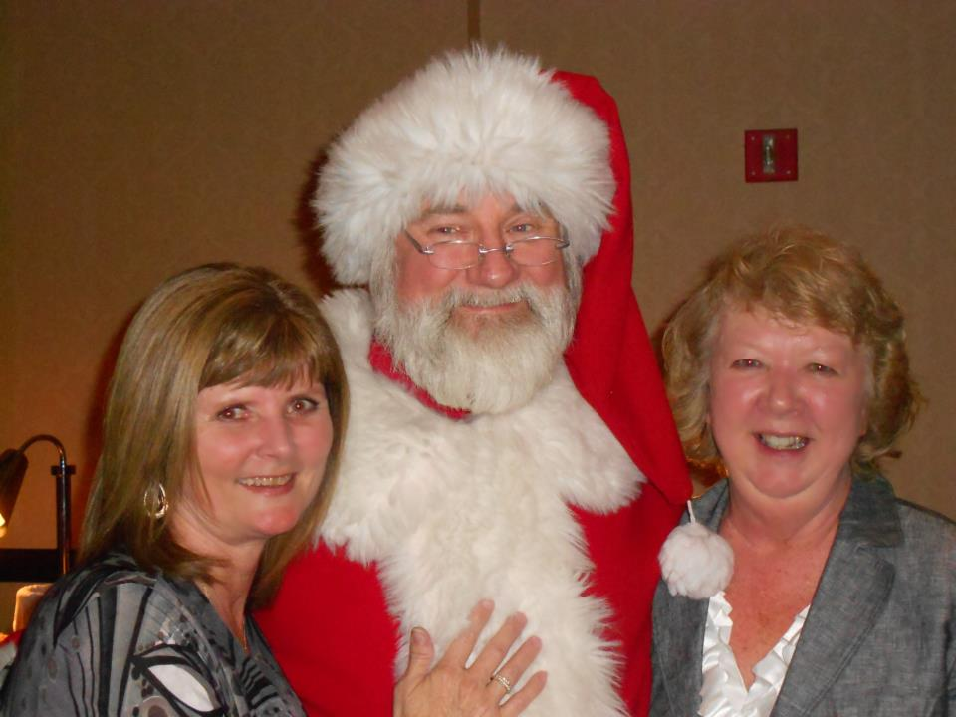
Events:
Banquets & Holiday Parties
Corporate Picnics
Corporate Conference
Grand Openings
Fashion Shows
Gala
Weddings
Vow Renewals
Anniversaries
Birthdays
Reunions
Fund Raisers
Proms and Formals
Military Balls
Santa Personality

High Profile Events:
Belk Events (Kid Fest, Ladies Night, Etc)
Sodexo Events on Liberty University Campus
VT Military Ball
Homestead Events

Come join us on Tuesday, December 10th for the RVSHRM Annual Holiday Event at Holiday Inn, Airport Valley View at 11:30 am.
Music ♫ Games ♫ Trivia ♫ Food ♫ Live/Silent Auction ♫ More
Bring your unwrapped toy and pay $10 or $20 for admission
Proceeds go to SHRM Foundation and Toys For Tots
Registration is NOW open!! Register TODAY!!

See you there~~~

